***Data Preprocessing***

*Data preprocessing is a crucial foundation in any data science, machine learning, or data analysis project. Raw data collected from real-world sources is often messy — it may include missing values, inconsistent formats, outliers, or irrelevant entries. Before we can perform any meaningful analysis or train a reliable machine learning model, the data must be cleaned, structured, and transformed. Preprocessing ensures that the data is accurate, consistent, and usable — turning raw information into a form that algorithms and analytical tools can interpret correctly. Without this step, even the most powerful models or statistical methods are likely to produce misleading or poor results.*

*Data preprocessing is the process of cleaning, organizing, and transforming raw data into a format that machine learning algorithms can understand and learn from. It includes key steps such as handling missing values, converting categories into numbers (called encoding), scaling numerical values to keep them in the same range, and selecting the most relevant columns (called features). Features are the input values the model uses to make predictions, while the label (also called the target) is the value it tries to predict — like predicting survival, price, or disease outcome.*

* ***A great way to understand data preprocessing is by comparing it to cooking a meal. Raw ingredients like vegetables or spices are not ready to serve on their own — they must be washed, chopped, measured, and combined properly. Similarly, raw data can’t be directly used for modeling. You need to clean it, transform it, and organize it before serving it to your machine learning model. Just as proper prep work in cooking leads to a better dish, proper data preprocessing leads to a more accurate and reliable model.***

*Data preprocessing is necessary because real-world data is often messy and not ready to use in machine learning. Many datasets contain missing values, wrong formats, text labels instead of numbers, or large differences in scale between columns. If we give this kind of data to a machine learning model, it may get confused, make poor predictions, or fail to learn anything at all.*

* ***For example, a model cannot understand text like "Male" or "Female" unless we convert it into numbers. If one column shows income in thousands while another shows age in single digits, the model might unfairly focus more on the bigger numbers. This is why we need***

***preprocessing — it cleans the data, makes sure it’s consistent, and turns it into a format the model can learn from.***

*In short, preprocessing helps the model understand the data properly. Without it, even the smartest algorithm can make big mistakes. That’s why preprocessing is considered the foundation of every successful data science or machine learning project.*

*During data preprocessing, we learn how to work with real-world datasets and get them ready for machine learning. First, we explore the dataset to understand how it’s structured and look for common problems like missing values or mixed data types. We then learn how to fix these issues by filling in missing values using methods like mean, median, or mode, or by removing columns with too many missing entries. We also learn how to turn text-based categories, such as gender or city names, into numbers using label encoding or one-hot encoding so that machine learning models can use them. Another important skill we learn is scaling numerical values like age or price to keep everything on a similar range, which helps the model treat all inputs fairly. We also practice choosing the most useful columns (called features) by checking how strongly they relate to the target we’re trying to predict. Finally, we learn how to separate features (inputs) from labels (outputs), and how to split the data into training and testing sets to build and test models. Altogether, these steps teach us how to clean, transform, and organize data in a way that makes it ready for building accurate machine learning models.*

**DATA PREPROCESSING WORKFLOW**

┌─────────────────────┐

│ 1. ***DATA COLLECTION***  │

│ (CSV/Excel/API/etc) │

└──────────┬───────────┘

▼

┌─────────────────────┐

│ 2. ***DATA CLEANING*** │

├─────────────────────┤

│ ▪ Fill missing values│

│ ▪ Remove duplicates │

│ ▪ Fix outliers │

│ ▪ Standardize text │

└──────────┬───────────┘

▼

┌─────────────────────┐

│ 3. EXPLORATORY DATA │

│ ANALYSIS (EDA) │

├─────────────────────┤

│ ▪ Check statistics │

│ ▪ Create visualizations│

│ ▪ Find correlations │

└──────────┬───────────┘

▼

┌─────────────────────┐

│ 4. FEATURE ENGINEERING│

├─────────────────────┤

│ ▪ Create new features│

│ ▪ Select best ones │

│ ▪ Scale/normalize │

└──────────┬───────────┘

▼

┌─────────────────────┐

│ 5. MODEL-READY DATA │

│ (Now feed to AI/ML!) │

└─────────────────────┘

***DATASET NAME :TITANIC -MACHINE LEARNING FROM DISASTER***

***Step 1:*** ***Upload and Load the Dataset***

**Code :- import pandas as pd**

***df=pd.read.csv(“dataset name /path uploading “)***

***What:***

* ***This line imports the pandas library and gives it the alias pd.***
* ***pandas is a Python library used for data manipulation and analysis.***
* ***It allows us to read datasets (like CSV files), clean, explore, and transform them using DataFrame objects.***

***Why:***

* ***It helps us load and explore the dataset from a CSV or Excel file.***
* ***Provides powerful tools to handle missing values, filter rows/columns, group data, merge datasets, etc.***
* ***It’s essential in almost every data preprocessing project in machine learning.***

***Result:***



***The DataFrame df now holds the entire dataset in a table format (like Excel).***

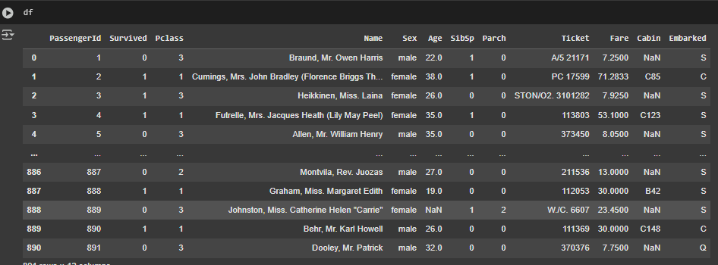

***Step 2: Data Exploration***

### ***code : df.shape***

### ***What:***

### ***Shows the number of rows and columns in df.***

#### ***Why:***

* ***To quickly see dataset size.***

***Result: → 891 rows and 12 columns.***

* 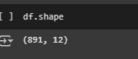

***code: df.columns***

### ***What:***

### ***Lists the column names in the DataFrame.***

#### ***Why:***

### ***To understand what features (columns) are available.***

#### ***Result:***

### 

***code: df.head()***

#### ***What:***

***Displays the first 5 rows of the dataset.***

#### ***Why:***

***To preview your data.***

#### ***Result:***

***Code: df.tail()***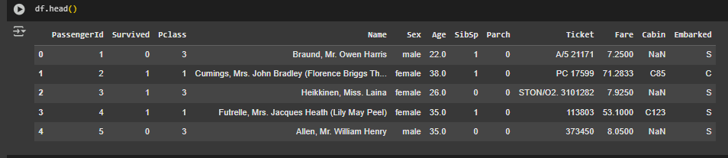

#### ***What:***

***Shows the last 5 rows of the dataset.***

#### ***Why:***

***To check for unexpected nulls or formatting issues at the end.***

#### ***Result:***

***You’ll see the bottom 5 entries of the Titanic dataset.***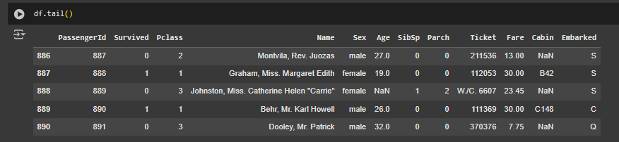

***Code: df.info()***

#### ***What:***

***Provides a summary of the dataset: column types, non-null counts.***

#### ***Why:***

***Helps identify missing values and data type mismatches.***

#### ***Result:***

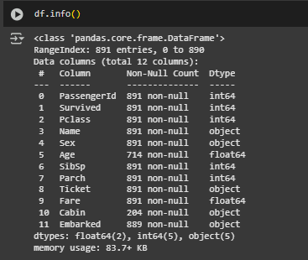

***code:df.describe()***

#### ***What:***

***Gives summary statistics for numeric columns.***

#### ***Why:***

***To understand distributions (mean, std, min, max), detect outliers.***

#### ***Result:***

#### ***Some numeric columns show outliers or unusual stats.***

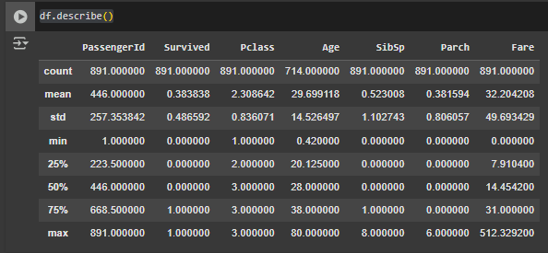

### ***code:df.duplicated().sum()***

#### ***What:***

***Checks for duplicate rows, and if any are found, removes the exact duplicates.***

#### ***Why:***

***Duplicates can bias the model and inflate metrics.***

#### ***Result:***

***If output is 0, your data has no full-row duplicates.The dataset becomes unique — no repeated rows.***

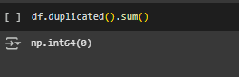

***Step 3 : Handle Missing Values***

### ***Code:df.isnull().sum()***

#### ***What:***

***Counts the number of missing (null) values in each column.***

#### ***Why:***

***Missing data must be handled — by dropping, imputing, or flagging.***

***Result:***

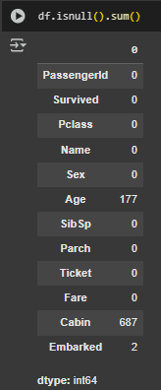

***code: df['Age'].fillna(df['Age'].median(), inplace=True)***

***df['Embarked'].fillna(df['Embarked'].mode()[0], inplace=True)***

***df.drop('Cabin', axis=1, inplace=True)***

***What:***

***Fill missing Age values with the median.***

***Fill missing Embarked values with the mode.***

***Drop the Cabin column entirely.***

***Why:***

***ML models can't handle NaNs.***

***Median is robust against outliers.***

***Cabin has too many missing values — better to drop it.***

***Result:***

***Age and Embarked have no missing values.***

***abin column is gone.***

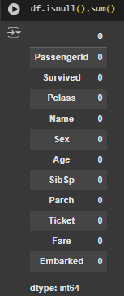

***Step 4 : Encode Categorical Variables***

***code: from sklearn.preprocessing import LabelEncoder***

***label = LabelEncoder()***

***df['Sex'] = label.fit_transform(df['Sex']) # male=1, female=0***

***df = pd.get_dummies(df, columns=['Embarked'], drop_first=True)***

***What:***

***LabelEncoder turns 'Sex' into numbers: male → 1, female → 0.***

***get_dummies() transforms Embarked into binary columns.***

***Why:***

***ML models only understand numbers, not text.***

***Result:***

***'Sex' becomes a binary column.***

***Embarked becomes Embarked_Q and Embarked_S.***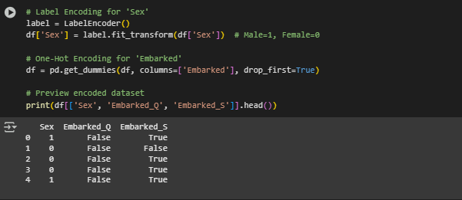

***Step 5: Scale Numerical Features***

***code: from sklearn.preprocessing import StandardScaler***

***scaler = StandardScaler()***

***df[['Age', 'Fare']] = scaler.fit_transform(df[['Age', 'Fare']])***

***What:***

***Standardizes Age and Fare (mean = 0, std = 1).***

***Why:***

***Scaling prevents features like Fare from dominating the model.***

***Result:***

***Scaled values like -1.2, 0.3, etc., instead of raw numbers.***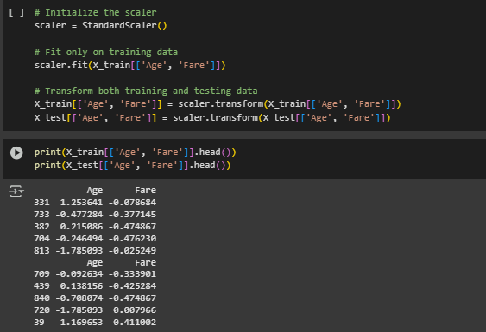

***Step 6: Feature Selection***

***code : features = ['Pclass', 'Sex', 'Age', 'SibSp', 'Parch', 'Fare', 'Embarked_Q', 'Embarked_S']***

***X = df[features]***

***y = df['Survived']***

***What:***

***Define feature set (X) and target label (y).***

***Why:***

***We only keep relevant columns to make the model efficient.***

***Result:***

***X = features***

***y = output label (Survived)***

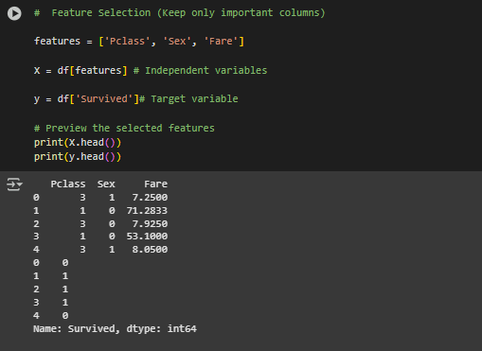

***Feature Selection – Correlation Matrix***

***code:***

***What:***

***Imports the two libraries used for data visualization.***

### ***Why:***

### ***seaborn: - For creating attractive and easy-to-read statistical plots like heatmaps.***

### ***matplotlib.pyplot: The underlying plotting engine for drawing graphs***

***Result:***

* ***These are required to draw the correlation heatmap in Step 5.***

***code :***

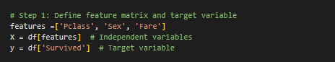

### ***What:***

***Defines the input features X and the target column y.***

### ***Why:***

***We’re analyzing how each feature (Pclass, Sex, Fare) correlates with the target (Survived).***

### ***Result:***

***X becomes a mini-dataset with 3 columns; y contains survival outcomes (0 or 1).***

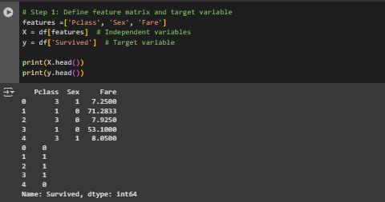

***code :***

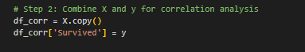

### ***What:***

***Creates a new DataFrame (df_corr) combining features and the target.***

### ***Why:***

***You need to compute correlation between each feature and the target (Survived), so they must be in one DataFrame.***

***Result:***

***df_corr looks like this:***

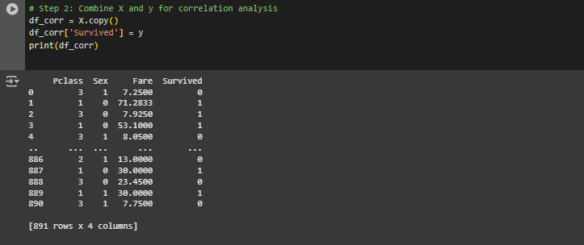

***code :***

***What:***

***Computes the correlation matrix between all numeric columns.***

### ***Why:***

***To measure how strongly each feature is linearly related to Survived.***

### ***Result:***

***Produces a matrix like:***

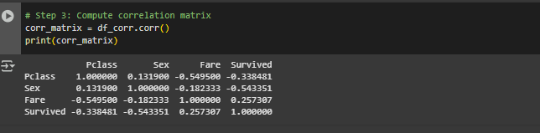

***code:***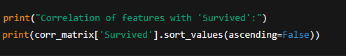

### ***What:***

***Prints how much each feature correlates with Survived.***

***Why:***

***This helps you rank features based on their predictive power (correlation strength).***

***Result :***

***(example from Titanic):***

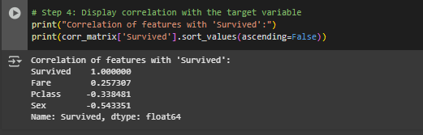

***Refer to the image in Step 5 for help***

***Code :***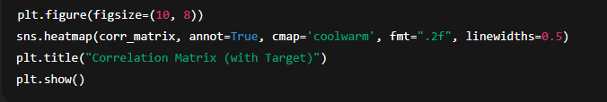

### ***What:***

***Plots a heatmap to visualize correlations between features and the target.***

### ***Why:***

***Visual representation helps to quickly identify strong or weak relationships.***

***Result:***

***You’ll see a heatmap where:***

* ***Red/Blue colors indicate strength/direction of correlation***
* ***Annotated numbers show exact values***
* ***Example:  
   🟥 Sex ↔ Survived = 0.54  
   🟦 Pclass ↔ Survived = -0.34***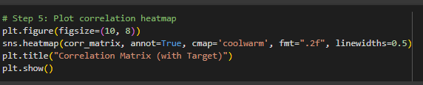

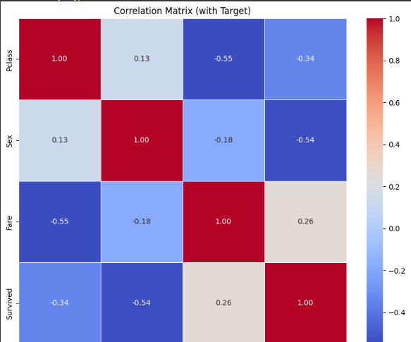

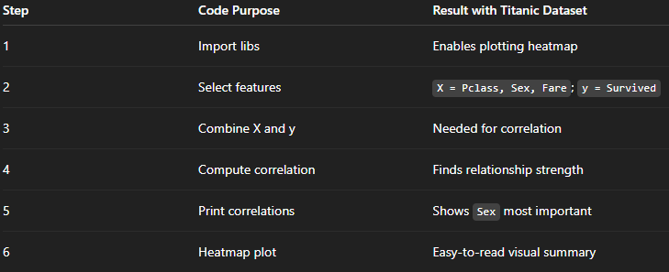

***After completing all the code, if want to see how the data looks, so can check the final output***

***df =df is the variable that holds the entire dataset. You can use it repeatedly to inspect the data after each step.***

***here is result:-***

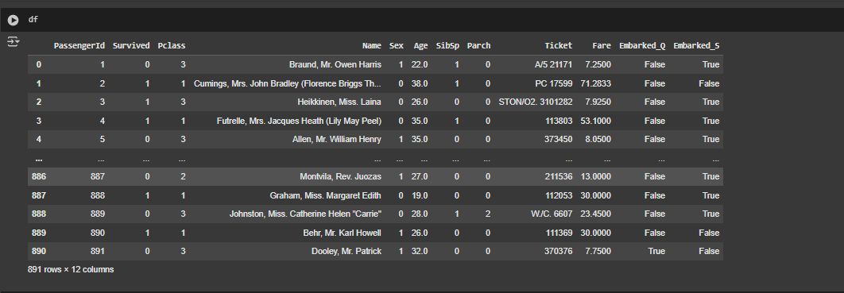

***Step 7: Data Splitting***

***Code***

## ***What :***

## ***This line splits your dataset into 4 parts:***

* ***X_train: input features for training***
* ***X_test: input features for testing***
* ***y_train: target values for training***
* ***y_test: target values for testing***

## ***Why :***

## ***In any machine learning course—like the popular Titanic dataset challenge—data splitting is a crucial step because:***

* ***The model learns from X_train, y_train.***
* ***We evaluate its performance on X_test, y_test (which it never saw during training).***
* ***This prevents overfitting and gives a realistic measure of how the model performs on unseen data.***

### ***Parameters explained:***

### ***\* test_size=0.2: 20% of the data is used for testing (the rest for training) * random_state=42: Ensures the same split happens every time ( for reproducibility, which is important for consistent model evaluation and debugging)***

## ***result :***

## ***Assuming your dataset (df) had 891 rows total (Titanic default):***

* ***80% for training → 712 rows***
* ***20% for testing → 179 rows***

***After running the code:***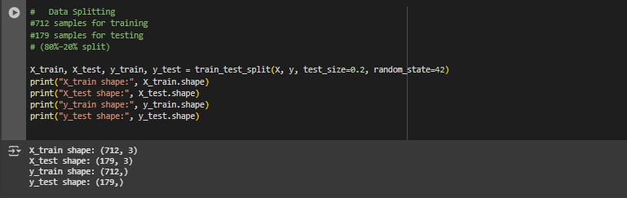

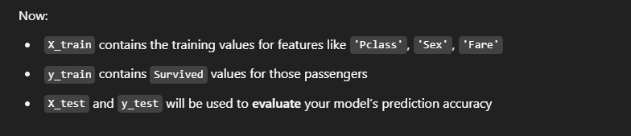

***The final dataset after preprocessing is shown below:***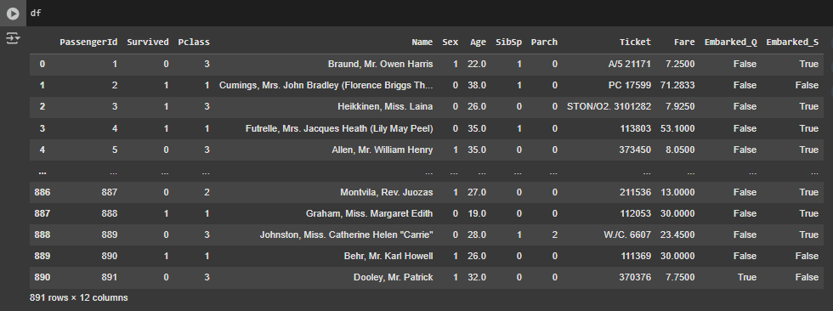

***Conclusion:***

***Data preprocessing plays a foundational role in the success of any machine learning project, and this file clearly demonstrates why. Through practical steps like handling missing values, encoding categorical variables, scaling numerical data, and selecting relevant features, we transformed a messy, real-world dataset into a structured, analysis-ready format. Each code block served a meaningful purpose — not only technically, but also in establishing good practices that every data scientist should follow when working with raw data.***

***By applying these preprocessing techniques to the Titanic dataset, we uncovered critical insights into which features were most predictive of survival. For example, we observed a strong positive correlation between gender and survival, while the passenger class had a negative relationship. These patterns could only be revealed after careful cleaning and preparation of the data. The feature engineering and visualization steps ensured that we kept only the most valuable inputs for model training, reducing noise and increasing model efficiency.***

***Ultimately, this file adds real value by showing how preprocessing transforms data from unusable to meaningful. It highlights that no machine learning model — no matter how advanced — can succeed with poor-quality data. The process illustrated here builds not just technical skills but also a deeper understanding of how thoughtful, step-by-step preprocessing can significantly improve the reliability, interpretability, and performance of any predictive model.***